**Lab-06**

**Name of Lab:** To Create VLAN and Testing its Connectivity

**Theory:**

A virtual local area network (VLAN) is a logical group of workstations, servers and network devices that appear to be on the same LAN despite their geographical distribution. A VLAN allows a network of computers and users to communicate in a simulated environment as if they exist in a single LAN and are sharing a single broadcast and multicast domain. VLANs are implemented to achieve scalability, security and ease of network management and can quickly adapt to changes in network requirements and relocation of workstations and server node

**Steps involved in Creating VLAN and Testing it’s Connectivity**

**Step 1:**

We opened the cisco packet tracer and it looked like figure below which is also the initial phase.

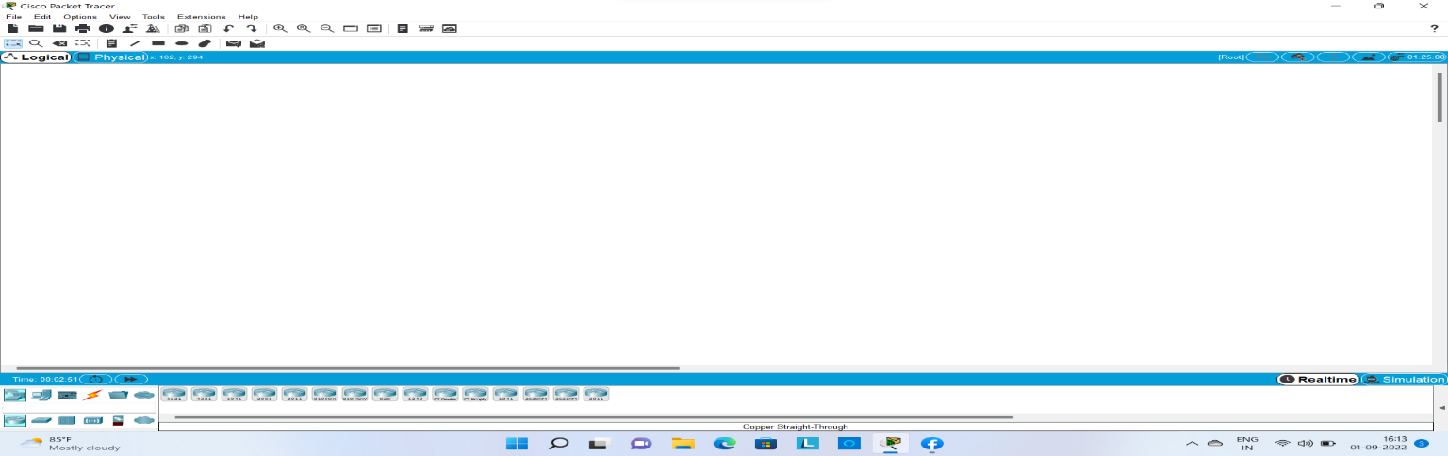

**Step 2:**

In this step we added network device required to create VLAN network

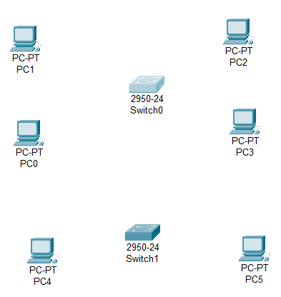

**Step 3:**

In this step we connected devices using straight through wire and cross through wire to construct VLAN as shown in figures below:

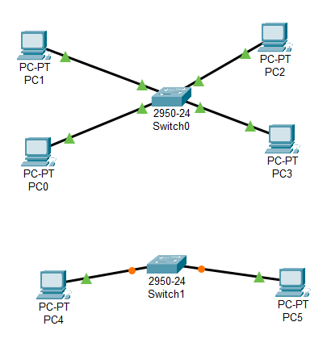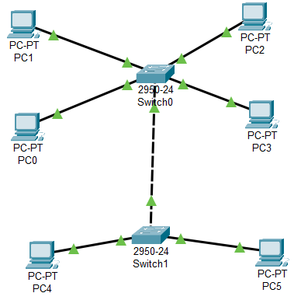

**Step 4:**

In this step we have assigned the device with internet protocol address (IP) address to all device of LAN1and LAN2 in same way as shown below:

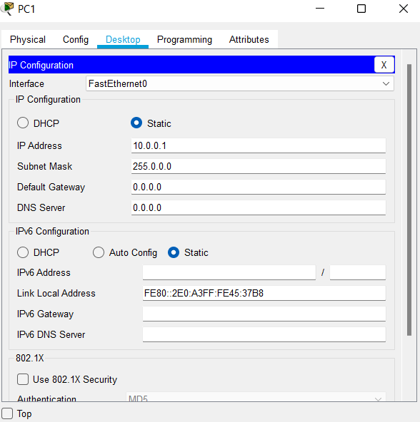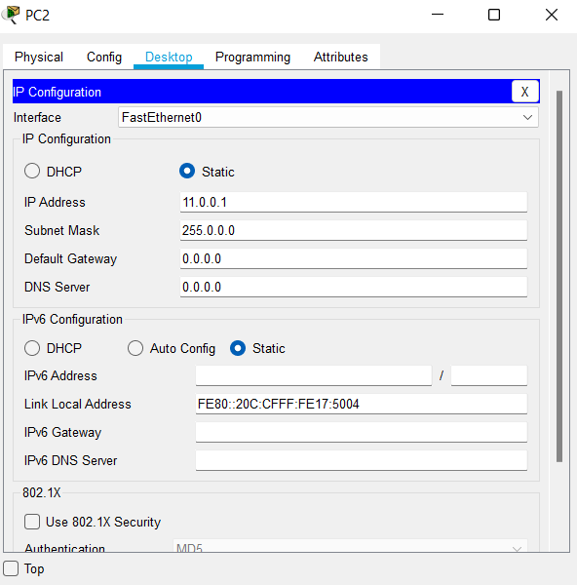

**Step 5:**

In this step we have assigned the device with VLAN number and VLAN name address to all device of LAN1and LAN2 in same way as shown below:

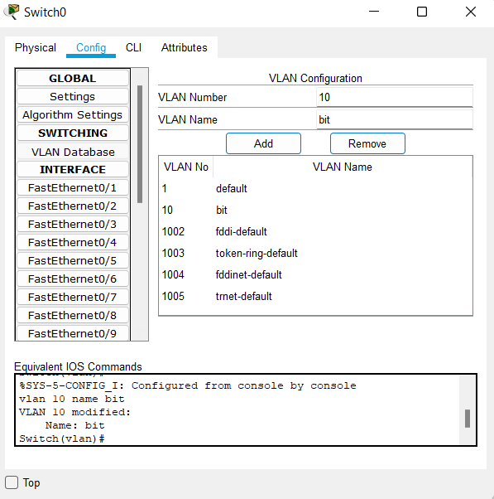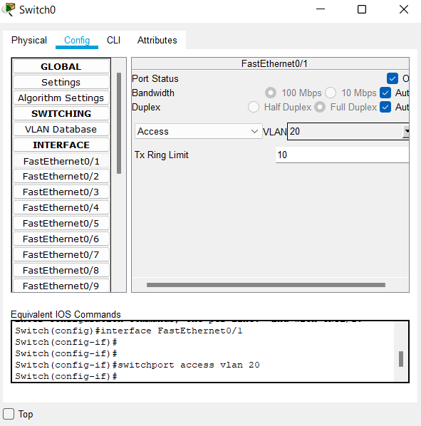

**Step 6:**

In this step we have pinged the device without configuring the switch to see what will happen which is shown in figure below:

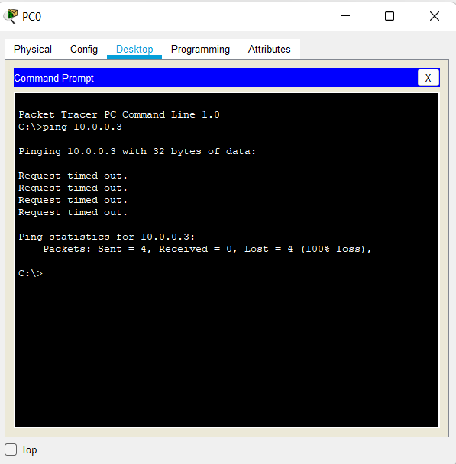

**Step 7:**

In this step we have configured the switch.

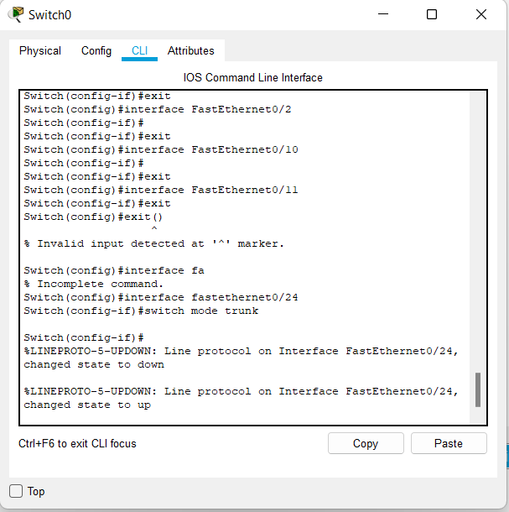

**Step 8:**

In this step, we verify the connectivity after configuring switch.

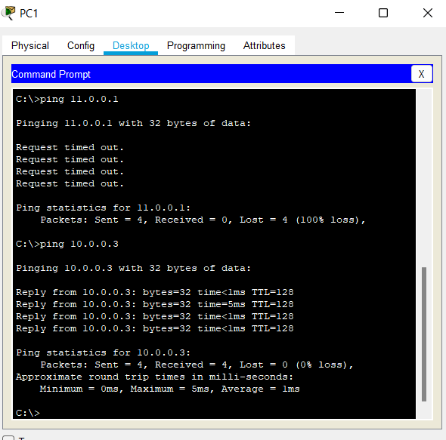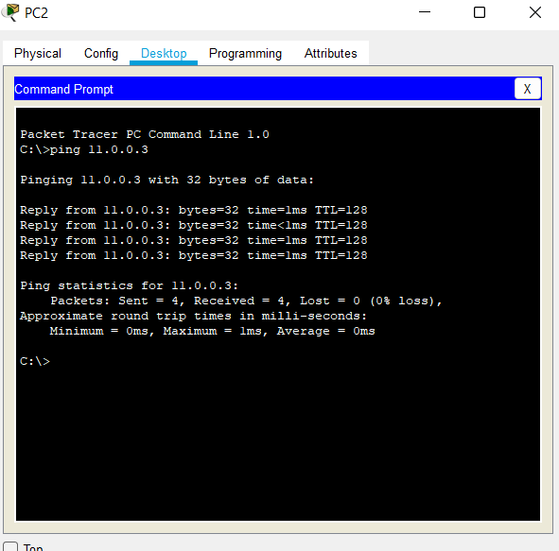

**Step 9:**

Verifying the connectivity by the process of **simulation** and various steps of simulation are shown below:

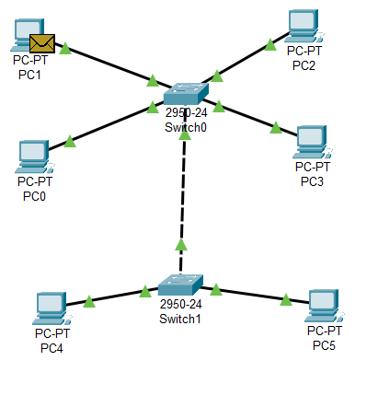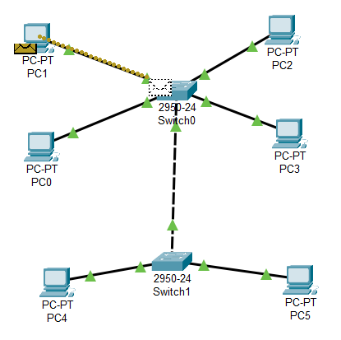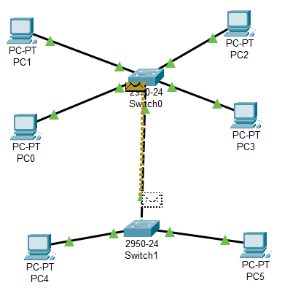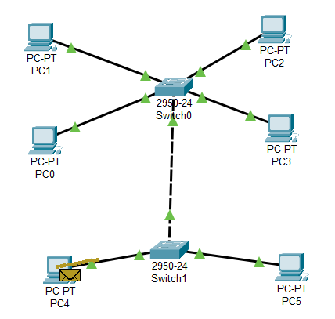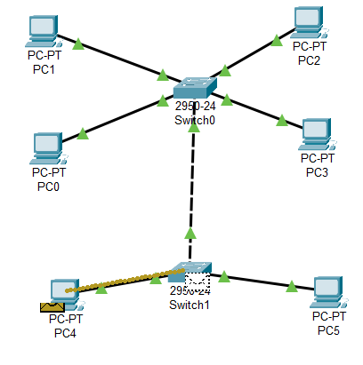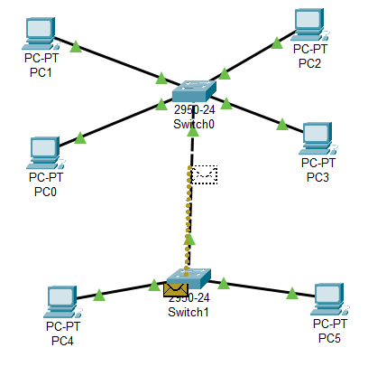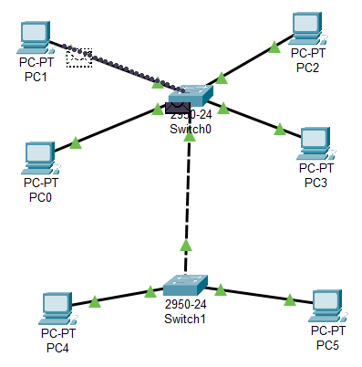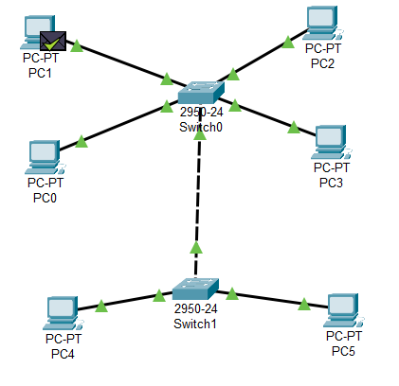

**Conclusion:**

Here in this, lab we came to conclude how Create VLAN and verified its connectivity.